PRESS-RELEASE
March 16, 2016

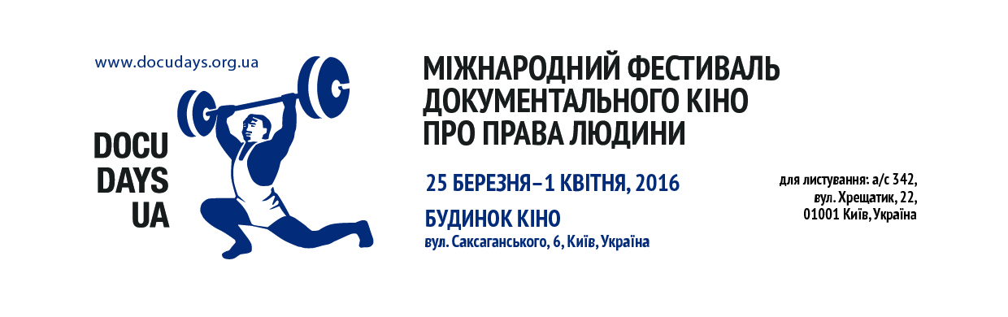
DOCUDAYS UA-2016 MAKES INTELLECTUAL BREAKTHROUGH THE ILLUSIONS

The 13th International Festival of Documentary Films on Human Rights Docudays UA opens its doors on 25 March 2016 and will keep them open until 1 April 2016 at “Cinema House” (6 Saksahanskoho St.), “Kyiv” Cinema (19 Velyka Vasylkivska St.), and “Kinopanorama” Cinema (19 Shota Rustaveli St.)
This year, the spectators will see 93 films from 43 countries from all over the world. Some 140 participants, including 60 guests from outside Ukraine will participate in this year’s festival. The festival will feature the works by Oscar laureates, winners of world documentary film festivals and, what’s very exciting, many films by Ukrainian directors.
This year’s Festival’s theme and programme goes BEYOND ILLUSIONS. Those are five powerful stories about the heavy road to writing a Constitution in Zimbabwe, on illusionary changes in Russia, about two sheriffs from Ukrainian village Stara Zburivka, brave human right defenders from Chechen Grozny city, as well as a documentary narration on the history of conflicts in Afghanistan and also about how simplification of “good versus bad” by the politicians provokes continuous wars and chaos.
The opening film is a real festival hit “Under the Sun” by Vitaly Mansky about the ideal life in an ideal country.
The Festival will home DOCU/UKRAINE national competition featuring 12 short documentaries on lives nowadays by young Ukrainian directors.
Besides, traditionally now, other competitions - DOCU/LIFE, DOCU/RIGHT і DOCU/SHORT - will take place as well. Every competition has its own separate jury in addition to student jury and audience who will pick their favourite works too.
Non-competition part of Docudays UA comprises 9 programmes. One of the audience’s favourite programme DOCU/BEST, will by tradition include winners of various festivals.
This year’s DOCU/ART programme discover the topic “Illusion Genre”, since all films not only tell stories of people of creative professions, but also put experiments of non-feature filmography.
Programme for children has expanded its age boundaries and changed its title to DOCU/YOUNG.
While restless inventors predict comfortable future for the mankind thanks to the work of machinery, sceptics envisage insidious demons in them. All the three films of DOCU/TECHNO show where these demons come from and, hence, what the future will look like.
The special programme WAYFARERS, devoted to issues of migration will not portray the “hordes of aliens”. Instead we will see the faces and hear voices who speak of their personal stories.
The programme RE-ACTION, offers three films, which bring us close to its main characters, who dare (in their own way) to withstand the system.
One of the most famous experts in documentaries Tue Steen Müller has prepared the special programme HIGH FIVE FROM DENMARK. It includes best Danish documentaries from previous years showcasing an evolution of documentary genre: from Jorgen Leth, teacher Lars von Trier, to young directors who practice selfie-film.
The American Festival TRUE/FALSE will present its programme as well. Its curator Pamela Kohn selected American films that resonate with Ukrainian realia. Three films – three stories of rebellious approach to education, on FBI special informants and on rehabilitation of discharged military personnel.
Parent movie-goers will have a chance to enjoy first-class films while their children (aged 3 to 14) will be looked after by the professional counselors in DOC/SADOC day care facility. In parallel to entertainment and educational events at the Festival, the Documentary Film School for Children 9-14 will take place within the Festival’s perimeters. During the school, trainees will meet young directors Alina Stepanenko and Dina Barinova.
Already fourth year in a row, the Docudays UA Festival will home DOCU/CLASS Documentary Film Workshop to allow renown and reputable directors, producers, photographers and script-writers deliver lectures. Also, guests are invited to visit a “Living library” during 26-31 March where visitors will be able to meet and talk to “live books” – people who are targeted for various societal biases.

SPECIAL SCREENINGS AND EVENTS
This year Docudays UA extends and invitation to the witness theatre. Documentary play “Mykolayivka” by Natalia Vorozhbyt and George Jenau – is a “fast theatre”, where actors do not play but share their personal stories. A theater that broadcasts reality in a form of a specific person and history. In “Mykolayivka” voices of students of the school # 3 are heard. Students, who survived the war. The play will take place on 26 March at 17:00 in DOCU/CLASS room.
The Guardian in Ukraine competition of documentary projects lasted in Ukraine for almost a year now was launched by one of the influential British media outlets The Guardian in partnership with Docudays UA and the British Council in Ukraine. The jury has already selected competition finalists and on 31 March at 15:00 best projects will be pitched. The winner will receive a GBP 5,000 grant and two runners-up will be awarded a GBP 3,000 grant from Docudays UA and the British Council for the production of their own documentaries. Admittance to the pitching – is free.
THE GUARDIAN DOCS special screenings will take place in the Blue Hall of “Cinema House” on 31 March , at 13:30.
The Festival will also accommodate “Ukrainian Dream” photo exhibition by Mikhail Friedman housed on a third floor of the “Cinema House” starting 26 March, at 16:00. Ukraine is in the midst of reforming of one of its most oppressive institutions - the police. Mikhail Friedman photo project explores the role of women in this process. According to Mikhail Friedman, there would be no progress without men- and women-dreamers. Thus, before, the Euromaidan dreamers imagined the Ukrainian Dream, while now this dream is dreamt by the policewomen”.
In January 2016, Docudays UA commenced a new project - See Ukraine: Docudays UA on tour. In 2016, the project will visit 5 countries: France, Germany, Italy, Spain, and Greece. The programme envisages screening of documentary films, photo exhibitions, meetings with Ukrainian film makers, as well as lectures and public events with participation of civic activists and human rights defenders, who will contribute to a better understanding of situations and phenomena portrayed in the films, while sharing more information about Ukraine.
To commemorate the 30th anniversary of Chernobyl disaster we will show “The Invisible City”, a film by director Viesturs Kairišs, who will personally present the film to the Ukrainian audience.

For more information on the festival, please contact Festival’s Press Officers Alisa Hordiychuk and Tetiana Mala at press@docudays.org.ua

Follow us on: www.docudays.org.ua, Facebook – http://www.facebook.com/DocudaysUA, Twitter – DocudaysUA та Instagram – docudays_ua, programme video reels available at our YouTube hannel – Docudays UA IHRDFF.

